PROJECT II

System (Application) Under Test - <https://restful-booker.herokuapp.com/>

In this Project, I use Postman API as testing and Java Script coding language for testing.

First I created a new Workspace named RB then starting to create Requests. Before starting testing, I declared 4 variables that I am going to use while I am testing.

The first one is {{url}} which contains the url of the site “<https://restful-booker.herokuapp.com>”, Second one is bookingID. bookingID is initialy null because I will declare its value while ım testing.

The third and the fourth are “firstname“ and “lastname “. They are also initially null. They are needed to hold the “firstname” and “lastname” information of the corresponding booking with Id is equal to bookingID.

The testing has 4 main requests:

1. **(POST :Booking)**

The URL is {{url}}/booking

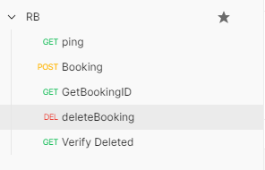A booking consisting following body format:

{"firstname":"<valid.value>",

"lastname":”<valid.value>",

"totalprice":”<valid.value>,,

"depositpaid":<valid.value>,,

"bookingdates":

{"checkin":"<valid.value>",

"checkout":"<valid.value>"},

"additionalneeds":"<valid.value>"}

For that I created a post method and fill the values inside for creating a post request for booking.



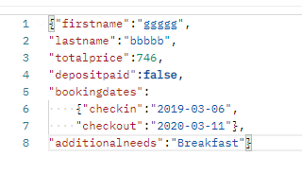The body of the post request is:

The codes of the test part is here:

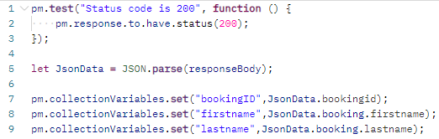

First I created a test for respond status. Than I took the responseBody, parsed it into a JSON data then I put it in a variable named JsonData. With this JsonData, I collect the datas for the Variables that I already create and put these data into variables. I choose bookingId, firstname and lastname as variables. This variables can accessed from other requests.

**2 (GET: GetBookingID)**

Get booking request that I just posted. As url I use {{url}}/booking/{{bookingID}}

So {{url}} means “<https://restful-booker.herokuapp.com>”

And {{bookingID}} means the created booking ID on POST request.

The codes of the test part is; 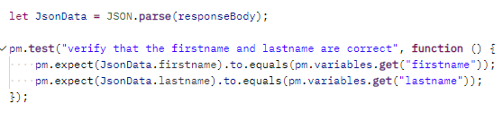

I again took the responseBody as a JsonData variable and I check if the information of the response text matches with the firstname and lastname variables which I just updated.

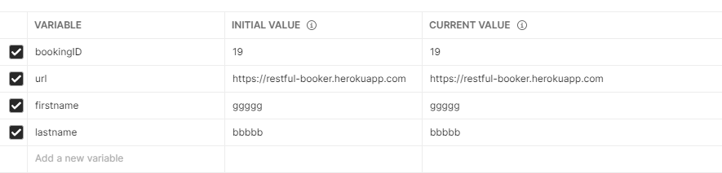

**3 (DELETE : DeleteBooking)**

Delete Booking. The URL is just same as phase 2 (see above). Only difference is Request Type and test codes. This time our Request Type is “Delete”.

In this part I needed two more headers to do this operation. The first one is

*KEY=Content-Type, Value = application/json*

and the second one is

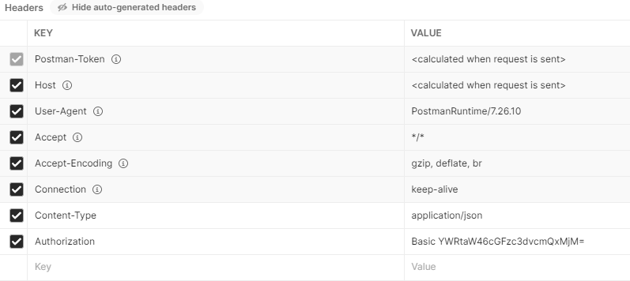 *KEY = Authorization, Value = Basic YWRtaW46cGFzc3dvcmQxMjM=*

And the codes of the test part is:



So I knew that if the operation done succesfuly the response must be “Created”. So I check if response is “Created” or not.

**4 (GET: VerifyDeleted)**

In this phase I am verifying that I deleted my Booking. The URL is same as phase 2 and 3 (see above). This time our Request Type is “Get” once again. The codes of the test part:

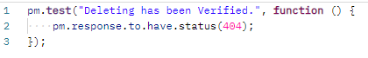

So I knew that if I delete my booking successfuly, I shouldn’t reach it with same URL again. The system must Show me the status of 404. So I checked that if the response status is equal to 404 or not.

